A Project Report

ON

ONLINE PORTAL FOR

CONDUCTING MCQ TEST

Submitted To: | Submitted By:
Mrs. Jyoti Snehi | Manik Chhabra
 | Manik Sharma
 | Mayank Marwaha
 | Nainika Aggarwal

INDEX

- Acknowledgement

- Certificate

- Introduction

- Software Development Methodology

- System Requirement Specification

- Introduction

*Purpose

*Scope

*Abbreviations

- References

- Overview *Overall Description *Product Perspective

2.1.1 System Interfaces

2.1.2 User interfaces

2.1.3 Hardware interfaces

2.1.4 Software interfaces

2.1.5 Communications interfaces

2.1.6 Memory constraints

2.1.7 Operations

2.1.8 Site Adaption Requirements

- Product functions

- User characteristics

- Constraints

- Assumptions and Dependencies

- Apportioning of requirements *Specific requirements *External interface requirements *User interfaces
*Faculty Registration screen *Faculty Login screen *Question Entering screen *Question deleting screen *Student Login screen *Student taking exam screen *Result displaying screen *Exam details entry screen *Student list entry screen

*Hardware interfaces

*Software interfaces

*Communications interfaces

*Software product features

*Faculty Registration process

*Validity checks

*Sequencing information

*Error handling/Response to abnormal situations *Faculty login management
*Validity checks

*Sequencing information

*Error handling/Response to abnormal situations

*Student login management

*Validity checks

*Sequencing information

*Error handling/Response to abnormal situations *Student taking exam management

*Validity checks

*Sequencing information

*Error handling/Response to abnormal situations

- Performance requirements

- Design constraints

- Software system attributes

*Security

*Maintainability

*Portability

- Logical Database Requirements

- Other requirements

- DFD

- ER-DIAGRAM

- Problem Description & Scope

- Hardware & Requirement

- Analysis & Report of the Present Manual System

- Steps In Feasibility Analysis

- Testing & Implementation

ACKNOWLEDGEMENT

We gratefully acknowledge for the assistance, cooperation, guidance and clarifications provided by Software Engineering teacher during the development of the Online Portal for conducting MCQ test website. Our extreme gratitude to Mrs. Jyoti Snehi who guided us throughout the project. Without his willing disposition, spirit of accommodation, frankness, timely clarification and above all faith in us, this project could not have been completed in due time.

His readiness to discuss all important matters at work deserves special attention. We would also like to thank whole of the faculty of the college for their cooperation and important support.

CERTIFICATE

This is to certify that the project entitled “Online Portal for Conducting MCQ

Test” has been developed by “Manik Chhabra, Manik Sharma, Mayank

Marwaha, Mohit Chawla and Nainika Aggarwal”.

They have worked on the project Online Portal for Conducting MCQ Test. They have used HTML, CSS, JAVASCRIPT, PHP and MYSQL as Database for the project. Their work is satisfactory.

I wish them all the best for their bright future.

Dated:- 04/10/2017 Project Incharge:- Mrs. Jyoti Snehi

INTRODUCTION

Education First is being launched because a need for a destination that is beneficial for both institutes and students. With this site, institutes can register and host online exams. Students can give exams and view their results. This site is an attempt to remove the existing flaws in the manual system of conducting exams.

Purpose

Online Portal For Conducting MCQ Test fulfills the requirements of the institutes to conduct the exams online. They do not have to go to any software developer to make a separate site for being able to conduct exams online. They just have to register on the site and enter the exam details and the lists of the students which can appear in the exam.
Students can give exam without the need of going to any physical destination. They can view the result at the same time.

Thus the purpose of the site is to provide a system that saves the efforts and time of both the institutes and the students.

What is Education First all about?

Education First is a web application that establishes a network between the institutes and the students. Institutes enter on the site the questions they want in the exam. These questions are displayed as a test to the eligible students. The answers enter by the students are then evaluated and their score is calculated and saved. This score then can be accessed by the institutes to determine the passes students or to evaluate their performance.

Education First provides the platform but does not directly participate in, nor is it involved in any tests conducted. Questions are posted not by the site, but users of the site. The site requires an institute to register before posting the questions. The site has an administrator who keeps an eye on the overall functioning of the system. The site gets revenue by charging the institutes each time they want to conduct the exam. The system entitled “Education First” is application software, which aims at providing services to the institutes and providing them with an option of selecting the eligible students by themselves. It is developed by using PHP technology and related database.

SOFTWARE DEVELOPMENT METHODOLOGY

The establishment and use of sound engineering principles in order to obtain economically developed software that is reliable and works efficiently on real machines is called software engineering.
Software engineering is the discipline whose aim is:

- Production of quality software

- software that is delivered on time

- cost within the budget

- satisfies all requirements.

Software process is the way in which we produce the software. Apart from hiring smart, knowledgeable engineers and buying the latest development tools, effective software development process is also needed, so that engineers can systematically use the best technical and managerial practices to successfully complete their projects.

A software life cycle is the series of identifiable stages that a software product undergoes during its lifetime .A software lifecycle model is a descriptive and diagrammatic representation of the software life cycle .A life cycle model represents all the activities required to make a software product transit through its lifecycle phases .It also captures the order in which these activities are to be taken .

Life Cycle Models

There are various life cycle models to improve the software processes.
WATERFALL MODEL
PROTOTYPE MODEL
ITERATIVE ENHANCEMENT MODEL
EVOLUTIONARY MODEL
SPIRAL MODEL

In the project, Waterfall model is followed.

WATERFALL MODEL

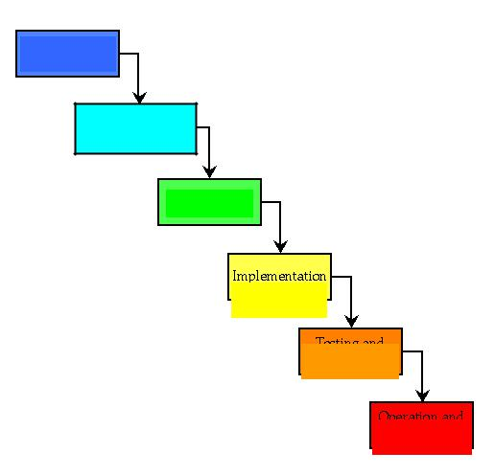

Feasibility

study

Requirement

Analysis and

Specification

Design

Implementation

and Unit testing

Integration and

System testing

Maintenance

WATERFALL MODEL

This model contains 6 phases:

- Feasibility study

The feasibility study activity involves the analysis of the problem and collection of the relevant information relating to the product. The main aim of the feasibility study is to determine whether it would be financially and technically feasible to develop the product.
- Requirement analysis and specification

The goal of this phase is to understand the exact requirements of the customer and to document them properly.(SRS)
- Design

The goal of this phase is to transform the requirement specification into a structure that is suitable for implementation in some programming language.
- Implementation and unit testing

During this phase the design is implemented. Initially small modules are tested in isolation from rest of the software product.
- Integration and system testing

In this all the modules are integrated and then tested altogether.
- Operation and maintenance.

Release of software inaugurates the operation and life cycle phase of the

operation.

The phases always occur in this order and do not overlap.

Software Requirement Specification (SRS)

- Introduction:

The following subsections of the SRS document provide an overview of the
entire SRS.

i) Purpose: The purpose of the project is to provide online facility to Institutes to conduct online exams and to Students to give online exams. Institutes can enter and edit the questions along with the students list. Also they can view the result there and will also be mailed to them. Students can login and give their respective exams and view their score then and there.

- Scope: The website to conduct online examination is “Education First”. This website provides facility to institutes to conduct online exams by providing a unique id to each institute. The institute provides questions along with positive marks. All the information entered can be later edited by the institute.

In turn student can login with their id, name and institute id to give the exams and can view their result then and there. Institutes can also view the result of their students.

Benefits: This website reduces the manual work, maintaining accuracy, increasing efficiency and saving time. Also institutes need not go to develop a new software each time, instead they just register and conduct a test. For students, it saves time of going to far away centers and also they can view their result then and there.

iii) Overview: The rest of this SRS document describes the various
system requirements, interfaces, features and functionalities in detail.

- Overall Description: In Online examination system institute can register to conduct a online test and view the records later. Students can give the test and their respective records, which include their marks for each test given by them, will be maintained separately. No student can take a particular exam more than once.

i.) Product Perspective:

- User interfaces
- A login screen for entering the username, password will be provided. Access to different screens will be based upon the user.

- There is a screen for displaying information regarding filling of exam details by institutes.

- There is a screen for displaying information menu regarding what options the institutes will select while filling entries(entering questions, student list, deleting questions, entering exam details).

- There is a screen for displaying exam details to the students when they are taking exams.

- There is a screen for taking exam for the students.

- There is a screen for displaying of results of students after taking the exam.
- Hardware interfaces

- Screen resolution of at least 800X600 is required for proper and complete viewing of screens. Higher resolution will be accepted.

- Software interfaces

  - Any windows based operating system.

  - Xampp providing Apache as the localhost and MySQL as the DBMS-for database.

  - IDE (NET BEANS) for developing code.

- Communications interfaces

None
- Memory Constraints
At least 512 MB RAM and 5 MB space on hard disk will be required for running the application.

(Xv) Site Adaptation Requirements

Web browser with cookies enabled.

ii.) Product Functions: The website will allow access only to authorised users with specific roles (Administrator- maintains the website, Institutes-Register to conduct the exams, Students-Give the exams online)

A summary of the major functions that the website will perform:

- Provide facility to institutes to register to conduct a online test.

- Institutes can enter the number of questions, marks, questions and answers.

- Students can login and give the tests.

iii.) User Characteristics:

- Educational level: Users should be comfortable with the English language.

- Experience: Users should have prior information regarding the online examinations.

- Skills: Users should have basic knowledge and should be comfortable using general purpose applications on computers.

iv.) Constraints:

- Due to limited features of DBMS being used performance tuning features will not be applied to the queries and thus the system may become slow with the increase in number of records being stored.

- An extra security as SSL must be used to secure the marks details and other examination information.

V.) Assumptions: The examinations are all objective. Students can give each exam just once.

- Apportioning of Requirements: The future versions of the website will be having a better database to handle larger number of records, in a more secure way. Also a portal containing practice papers for various subjects will be made later.

- Specific Requirements: This section provides software requirements to a

level of detail sufficient to enable designers to design the system and testers to test the system.

External Interface Requirements:

- User Interfaces:

*Faculty Registration Screen: Various fields

available on this screen will be:

*Login Name
*Subject Name

*Email Id

*Password

*Faculty Login Screen: Fields available on this

screen are:
*Login Name

*Password

*Entering Questions: Various Fields are:

*Questions

*Options (4)

*Correct Answer

*Exam Details Screen: Various Fields are:

*Exam Name

*No. Of Questions

*Marks

*Student List Screen: Various Fields are:
*Student ID

*Student Name
*Email Id
*Phone Number

*Student Login Screen: Various Fields are:

*Student ID

*Student Name

*Student Taking Exam Screen: Various Fields are:

*Display Of Question With Options

*Timer displaying time of the test

*Result Displaying Screen: Various Fields are:

*No. Of Correct Questions
*No. Of Incorrect Questions

*Total Marks.
*Result

*Hardware interfaces:

*Screen resolution of at least 800X600 is required for proper and complete viewing of screens. Higher resolution will be accepted.

*Software interfaces:
*Any windows based operating system.
*Xampp providing Apache as the localhost and MYSQL as the DBMS-for database.

*IDE (NET BEANS) for developing code.

*Communications interfaces

None

ii.) Software Product Features:

Validity Checks:

Javascript provides validity checks for various fields in the forms.
Sequencing Information: All the information

regarding exam details, student list, question details, display of result should be handled sequentially that is data should be stored only in a particular sequence to avoid any inconvenience

Error Handling: If any of the validations or sequencing flows does not hold true then appropriate error messages will be prompted to the user for doing the needful.

iii.) Performance Requirements: This subsection specifies numerical requirements placed on the software or on the human interaction with the software, as a whole. Numerical requirements will include:

*Only text information will be supported(HTTP)

*All the transactions will be processed within seconds.

iv.) Design Constraints: None

v.) Software System Attributes:
*Security: Only authorized users will be able to access the website by entering the correct login name and corresponding password.

*Maintainability: The website can be maintained in present or future. It will be easy to incorporate new requirements in the individual modules.

*Portability: As the website is online so will be easily portable on various systems. The website will be also easily portable on any windows based system that has Xampp and Netbeans installed.

*Logical Database Requirements: The following information will be placed in the database:

*Faculty Details: ID, Login Name, Email, Password, Subject Code, Department.
*Institute Student List: Sname, Roll_no., Department, Phone, Email.
*Institute Question Details: Question_id, Subject_code, Question_name,
Opt1, Opt2, Opt3, Opt4, Answer. .

*Institute Subject Details: Subject_id, Subject_name.
* Institute Result Details: Id, Sname, Subject_code, Score.

*Other Requirements: None

DATA FLOW DIAGRAM

A DFD also known as ‘bubble chart’, has the purpose of clarifying system requirements and identifying major transformations. It shows the flow of data through a system. It is a graphical tool because it presents a picture. The DFD may be partitioned into levels that represent increasing information flow and functional detail. Four simple notations are used to complete a DFD. These notations are given below:-

DATA FLOW:- The data flow is used to describe the movement of information from one part of the system to another part. Flows represent data in motion. It is a pipe line through which information flows.

Data flow is represented by an arrow.

PROCESS:- A circle or bubble represents a process that transforms incoming data to outgoing data. Process shows a part of the system that transform inputs to outputs.


PROCESS

EXTERNAL ENTITY:- A square defines a source or destination of system data. External entities represent any entity that supplies or receive information from the system but is not a part of the system.

EXTERNAL

ENTITY

DATA STORE:- The data store represents a logical file. A logical file can represent either a data store symbol which can represent either a data structure or a physical file on disk. The data store is used to collect data at rest or a temporary repository of data. It is represented by open rectangle.

DATA STORE

OUTPUT:-The output symbol is used when a hard copy is produced and the

user of the copies cannot be clearly specified or there are several users of the output.

OUTPUT 

LEVEL ‘0’ DFD FOR ONLINE EXAMINATION

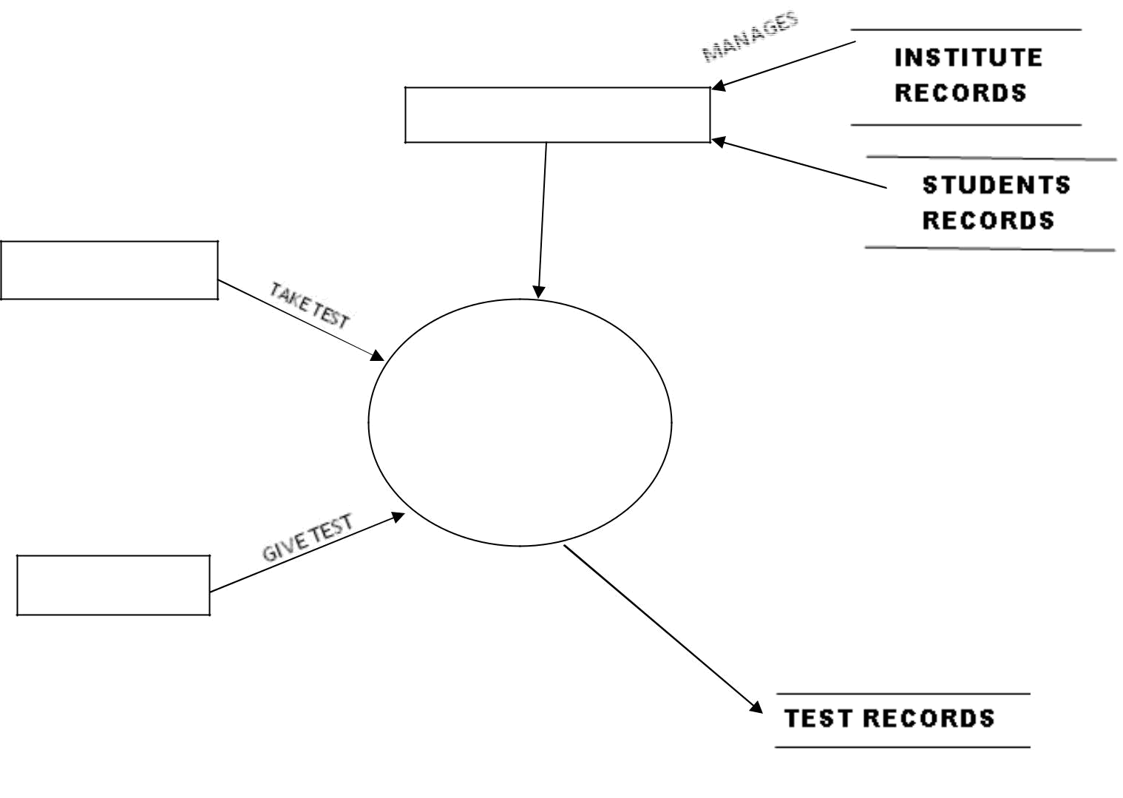

ADMINISTRATOR

RESULT

INSTITUTE

EXAMINATION

STUDENT

LEVEL ‘1’ DFD

 |  |  |  |  |  |  |  | QUESTION PAPER
 | INSTITUT-E |  |  | enter
 |  | Register
 |  |  |  | Enter |  |  |  |  | INSTITUTE PROFILE
 |  | REGISTER
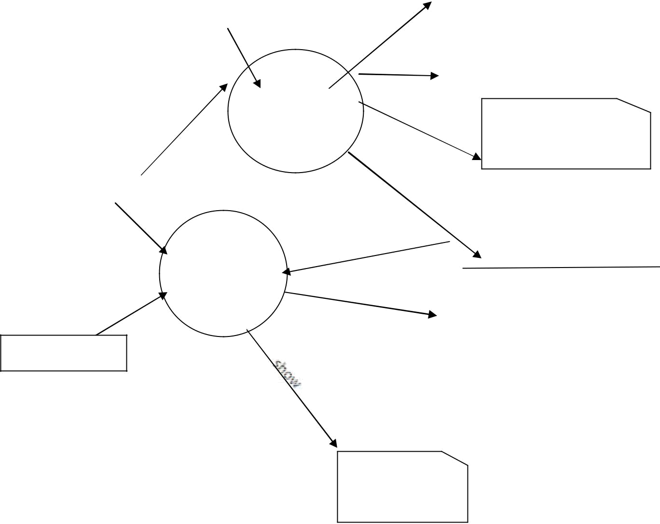
 |  | manages |  |  |  |  |  |  | ready
 |  |  |  | enter |  |  |  |  | REGISTER
ADMINISTRT
OR
manages
 |  | GIVE |  | use |  |  |  | STUDENTS RECORDS
 |  | EXAM
 |  |  |  | results
Authorized
 |  |  |  |  |  |  | TEST RESULTS


STUDENTS

DISPLAY
RESULT

PROBLEM DEFINITION

A website, EDUCATION FIRST, is to be designed to conduct online tests. Unlike other online examination systems this website should not be just for the students, instead it should also provides facility to Institutes to host online Tests/Exams. This will help institutes as:

There will be no need to get new software every time to conduct an online test.

Also like other online websites, it will help students by:

Saving the extra time of going to far away Exam Centre. Students need not wait for their results.

Also this website will remove the flaws of existing Manual Systems like:

Reducing the manual labour (Decreases Overheads). Avoiding Mistakes Due To Human Error (Accurate). Will Increase Efficiency and Save Time.

Will Allow Neat Handling Of Data Rather Than Error Prone Records.

The faculty will register themselves with a unique login name and password.

After login:

- They will enter exam details like number of questions, marks.

- Then they will enter the questions along with the answers which can later be deleted and edited.

- Faculty will be able to view the students list along with their respective results.

Also for students:

- They should be able to login with their roll number, name and password.

- They should be able to give the exam as per the details entered by respective faculty.

- Also they should be able to view their score after test finishes and result will also be mailed to their mail id’s.

- If already given the test then they will be displayed the message that test has been already given.

- The questions should be selected randomly from the database.
- If the student tries to give test from another tab, then they will be displayed the result “don’t try to cheat and give test from another tab”.

FUNCTIONAL REQUIREMENTS

It deals with the functionalities required from the system which are as follows:

The website will help the colleges/organizations/companies to conduct their online exams.

Only authorized person can access related details.

The organization will register themselves on the website for conducting their exams.

Organizations can change their information regarding themselves.



The students can login through ROLL NUMBER and PASSWORD and give their exams.

Administrator will be responsible for updating the site.



The organization can change questions and test papers whenever they want.

The technologies used to develop this site are:-

FRONTEND:- (LANGUAGES)

PHP:- PHP is a server-side scripting language designed primarily for web development but also used as a general-purpose programming language. Originally created by Rasmus Lerdorf in 1994, the PHP reference implementation is now produced by The PHP Development Team.
PHP originally stood for Personal Home Page, but it now stands for the recursive acronym PHP: Hypertext Preprocessor.

HTML:- Hypertext Markup Language (HTML) is the standard markup language for creating web pages and web applications. With Cascading Style Sheets (CSS) and JavaScript it forms a triad of cornerstone technologies for the World Wide Web. Web browsers receive HTML documents from a webserver or from local storage and render them into multimedia web pages. HTML describes the structure of a web page semantically and originally included cues for the appearance of the document.

BACKEND:- (DATABASE)

MYSQL:- SQL is a domain-specific language used in programming and designed for managing data held in a relational database management system (RDBMS), or for stream processing in a relational data stream management system (RDSMS).
Originally based upon relational algebra and tuple relational calculus, SQL consists of a data definition language, data manipulation language, and data control language. The scope of SQL includes data insert, query, update and delete, schema creation and modification, and data access control. Although SQL is often described as, and to a great extent is, a declarative language (4GL), it also includes procedural elements.

NON FUNCTIONAL REQUIREMENTS

They are the quality requirements that stipulate how well a software does what it has to do.

Performance

No. of terminals to be supported is dependent on the server that we will use at the time of deployment.

The web application server used should provide good performance and ability to manage performance with techniques such as support for caching.

After completing the exam, the entire score of the student will be calculated as per the rules in less than a second.

Availability



Online Examination site has 24*7 availability. It can be accessed for 24 hours a day.

Students can take exam only during the previously allotted time slots, however can open

site anytime to access other information.

Colleges can register for the exam anytime.

Reliability

It means the extent to which program performs with required precision.
The website developed should be extremely reliable and secure so that information about any questions etc. is not leaked before the actual exam is held.

Usability

The website should be user friendly and should require least effort to operate.

The web server used should provide services like session management to maintain sessions in the application.

Portability



The website is made using HTML, etc.which are platform independent and can be transported to other servers with minimum effort.

Flexibility

It is effort required to modify operational program. The whole website should be made using independent modules so that any changes done in 1 module should not effect the other one and new modules can be added easily to increase functionality.

What contribution would the project make?

This is an era of information technology where automation of each and every activity is gaining importance. The site will lead to the automation of the examination system. Moreover it is far better than the previous such websites.

Computerized vs. Manual Examination System

Automated process of examination is much better than the manual system as it has following advantages:

- Time saving

- Increased efficiency

- Allows neat handling of data rather than error prone records.

- Decreases overhead

- Accurate

FEASABILITY STUDY

Once scope has been identified (with the concurrence of the customer), it is reasonable to ask: “Can we build software to meet this scope? Is the project feasible?” All too often, software engineers rush past this questions (or are pushed past them by impatient managers or customers), only to become mired in a project that is doomed from the onset.

When we are developing the system (software), we must know the proposed system will be feasible or i.e. practically implemented or not it may possible the proposed( candidate ) system may not implemented due to many reasons like it may take long time in development than the specified time limit ,cost may increase than proposed one etc. Therefore we must analyze the feasibility of the system.

Feasibility is the analysis of risks, costs & benefits relating to economics, technology & user operation.

There are several types of feasibility depending on the aspect they covers. Some important feasibilities is as follows:-
(I) Technical Feasibility

- Operational Feasibility III) Economical Feasibility

TECHNICAL FEASIBILTIY:-

The technically feasibility study basically centers on alternatives for hardware, software and design approach to determine the functional aspects of system.

This project on Online Examination will be platform independent since it is being coded in JAVA language (using JSP and SERVLETS).HTML is used to create web pages.

MS-Access database will be used for storing data.

Hardware requirements used are compatible with all O.S. Only authorized person would be able to use the website so it would be secure. The system can also be expanded as per the needs of requirement specification.

OPERATIONAL FEASIBILTY:-

Operational Feasibility is a measure of how people are able to work with system. This type of feasibility demands if the system will work when developed and installed.

Since website is very user friendly so users will find it comfortable to work on this site.

ECONOMICAL FEASIBILITY

Economic analysis is the most frequently used evaluating the effectiveness of proposed system, more commonly known as Benefit analysis. The Benefit analysis is to determine benefits and savings which are expected from candidate system and compare them with cost. If the benefits are more than the cost, then decision is made to design and implement the system. The cost and benefits may be direct or indirect and tangible or intangible.

TESTING

Software testing is the process of executing a program with intension of finding errors in the code. It is a process of evolution of system or its parts by manual or automatic means to verify that it is satisfying specified or requirements or not.

Generally, no system is perfect due to communication problems between user and developer, time constraints, or conceptual mistakes by developer.

To purpose of system testing is to check and find out these errors or faults as early as possible so losses due to it can be saved.
Testing is the fundamental process of software success.

Testing is not a distinct phase in system development life cycle but should be applicable throughout all phases i.e. design development and maintenance phase.
Testing is used to show incorrectness and considered to success when an error is detected.

OBJECTIVES OF SOFTWARE TESTING

The software testing is usually performed for the following objectives:-

SOFTWARE QUALITY IMPROVEMENT:- The computer and the software are mainly used for complex and critical applications and a bug or fault in software causes severe losses. So a great consideration is required for checking for quality of software.

VERIFICATION AND VALIDATION:-

Verification means to test that we are building the product in right way .i.e. are we using the correct procedure for the development of software so that it can meet the user requirements.
Validation means to check whether we are building the right product or not. SOFTWARE RELIABILTY ESTIMATION:- The objective is to discover the residual designing errors before delivery to the customer. The failure data during process are taken down in order to estimate the software reliability.

PRINCIPLES OF SOFTWARE TESTING

Software testing is an extremely creative and challenging task. Some important principles of software testing are as given:-

All tests should be traceable to customer requirements.

Testing time and resources should be limited i.e. avoid redundant testing.

It is impossible to test everything.

Use effective resources to test.

Test should be planned long before testing begins i.e. after requirement phase.

Test for invalid and unexpected input conditions as well as valid conditions.

Testing should begin in “in the small” and progress towards testing “in the large”.

For the most effective testing should be conducted by an independent party.

Keep software static (without change mean while) during test.

Document test cases and test results.

Examining what the software not doing which it expected to do and also checking what it is doing that was not expected to do.

STRATEGY FOR SOFTWARE TESTING

Different levels of testing are used in the test process; each level of testing aims to test different aspects of the system.

The first level is unit testing. In this testing, individual components are tested to ensure that they operate correctly. It focuses on verification efforts.
The second level is integration testing. It is a systematic technique for constructing the program structure. In this testing, many tested modules are combined into the subsystem which are then tested. The good here is to see if the modules can be integrated properly.
Third level is integration testing. System testing is actually a series of different tests whose primary purpose is to fully exercise computer based system. These tests fall outside scope of software process and are not conducted solely by software engineers.

BIBLIOGRAPHY

The following books were very helpful during the completion of project:

Software Engineering

-K.K. Aggarwal and Roger Pressman

